LAB PROGRAMS
CSA1015-SOFTWARE ENGINEERING

Step 1: Log in to your Jira account, click Create Project, and select the Kanban project template.
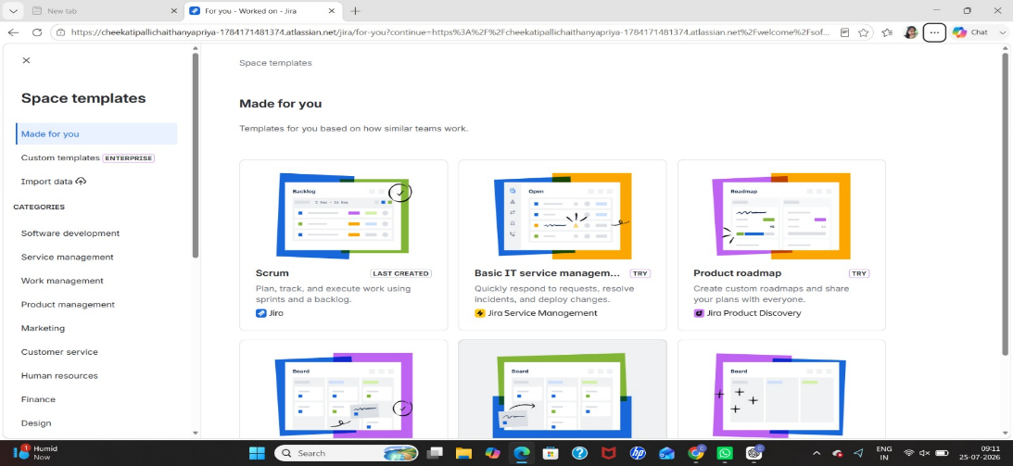
Step 2: Enter the project name, select the required settings, and click Create to create the Kanban project.
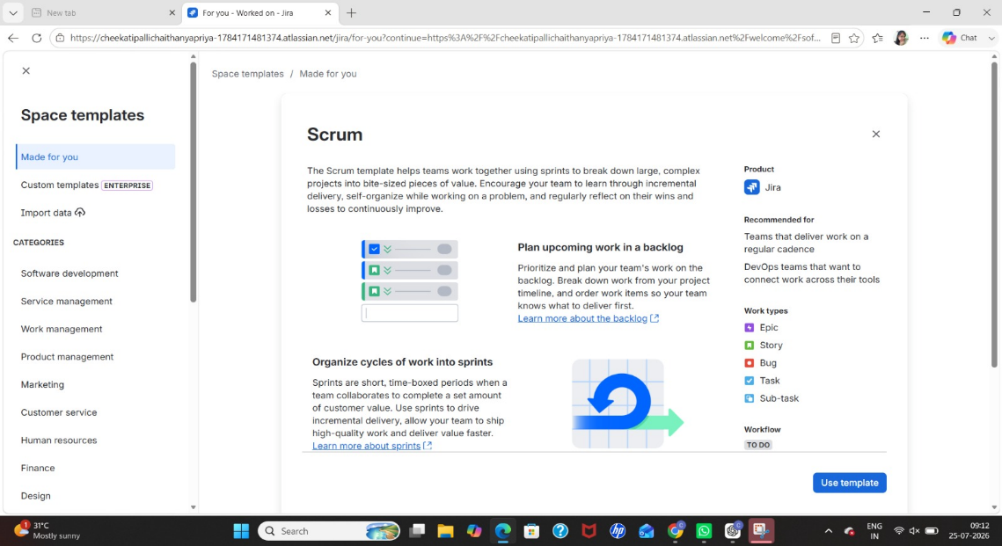

Step 3: Open the project board and create the required tasks. Assign the tasks, set the priority, and save them.

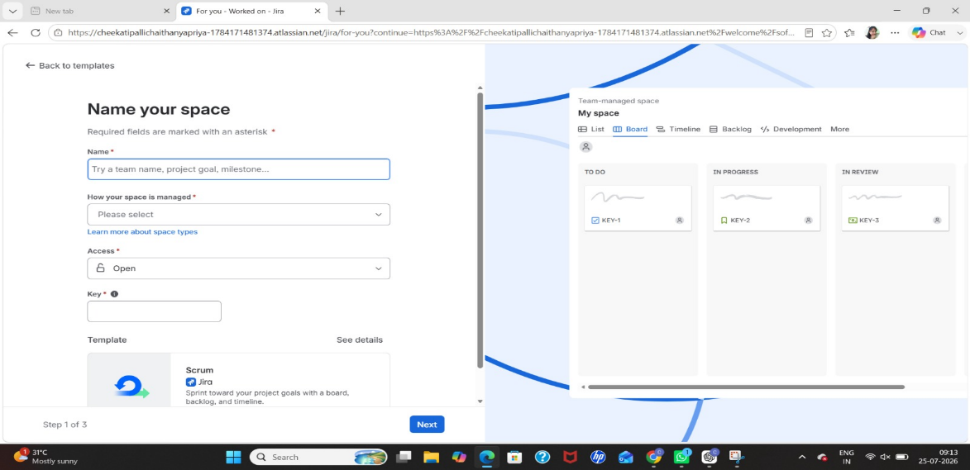

Step 4 : Add all the task to list
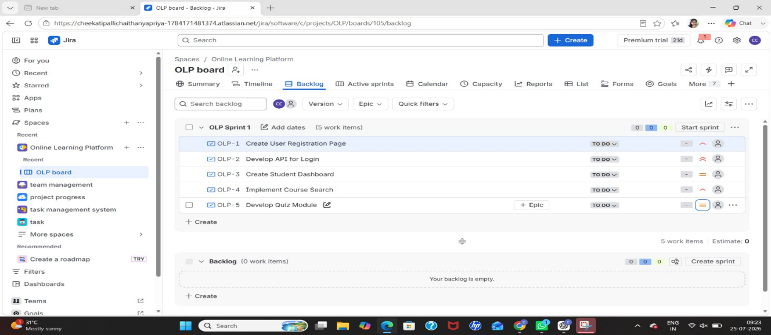

Step 5: Open the Summary page to verify the project details, priority distribution, and team workload.
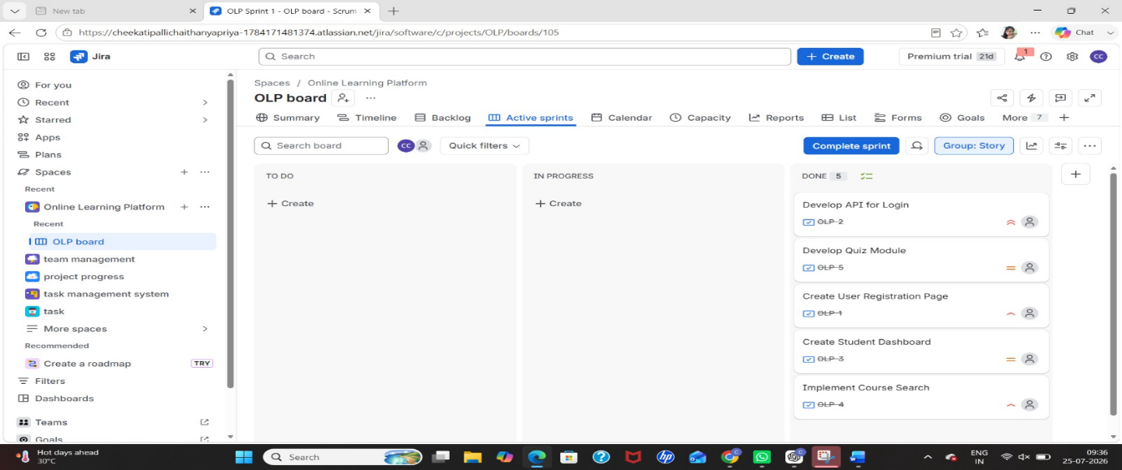
Step 6: Open the List view to verify all the created tasks with their assignee, reporter, priority, and current status.

